Lab 6
Question 1:
#include <stdio.h>

int main() {
int n;
printf("Enter the number of elements: ");
scanf("%d", &n);
int array[n];
printf("Enter %d elements:\n", n);
for (int i = 0; i < n; i++) {
scanf("%d", &array[i]);
}
printf("You entered:\n");
for (int i = 0; i < n; i++) {
printf("%d ", array[i]);
}
printf("\n");
return 0;
output :
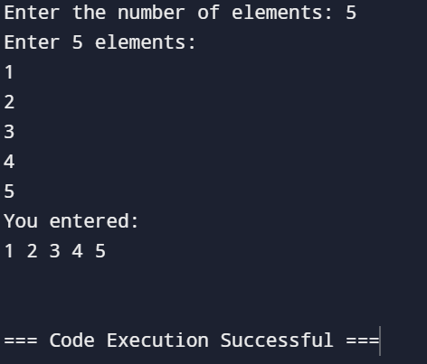

Question 2:
#include <stdio.h>
int main()
{
int size;
printf("Enter size of the array: ");
scanf("%d",&size);
int arr[size];
printf("Enter array elements\n")
for(int i=0;i<size;i++)
scanf("%d",&arr[i]);
int sum=0;
for(int i=0;i<size;i++)
sum+=arr[i];
printf("Sum of the array is: %d",sum);
return 0;
}

Output:
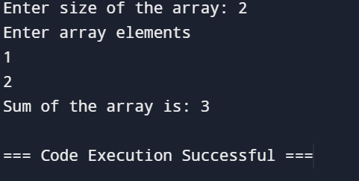

Question 3:

#include <stdio.h>

int main() {
int n, i, search, flag = 0;
int arr[100];
printf("Enter the number of elements in array: ");
scanf("%d", &n);

printf("Enter %d integers:\n", n);
for(i = 0; i < n; i++) {
scanf("%d", &arr[i]);
}

printf("Enter the element to search: ");
scanf("%d", &search);

for(i = 0; i < n; i++) {
if(arr[i] == search) {
printf("Element found at position: %d\n", i);
flag = 1;
break;
}
}

if(flag == 0) {
printf("Element not found in the array.\n");
}

return 0;
}

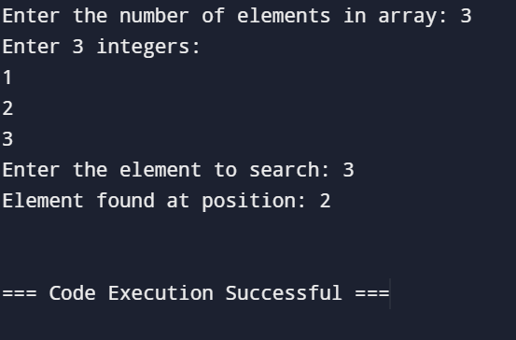

Question4:
#include <stdio.h>

int main() {
int n;

printf("Enter the number of elements in the array: ");
scanf("%d", &n);

if (n <= 0) {
printf("Array is empty.\n");
return 0;
}

int arr[n];

printf("Enter the elements of the array:\n");
for (int i = 0; i < n; i++) {
scanf("%d", &arr[i]);
}

int smallest = arr[0];
int largest = arr[0];

for (int i = 1; i < n; i++) {
if (arr[i] < smallest) {
smallest = arr[i];
}
if (arr[i] > largest) {
largest = arr[i];
}
}

printf("Smallest number: %d\n", smallest);
printf("Largest number: %d\n", largest);

return 0;
}
Output:
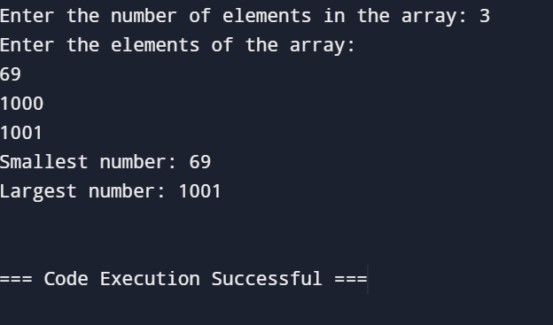

Question5:
#include <stdio.h>

void bubbleSort(int arr[], int n) {
for (int i = 0; i < n-1; i++) {
for (int j = 0; j < n-i-1; j++) {
if (arr[j] > arr[j+1]) {
int temp = arr[j];
arr[j] = arr[j+1];
arr[j+1] = temp;
}
}
}
}

int main() {
int n;

printf("Enter the number of elements in the array: ");
scanf("%d", &n);

int arr[n];

printf("Enter the elements of the array:\n");
for (int i = 0; i < n; i++) {
scanf("%d", &arr[i]);
}

bubbleSort(arr, n);

printf("Sorted array:\n");
for (int i = 0; i < n; i++) {
printf("%d ", arr[i]);
}
printf("\n");

return 0;
}

Output:
